Hi guys,
I'm sending this to those who are working on the Literature and English course outline revisions. Since the Curriculum deadlines for spring are underway, let's decide if we would like to start putting our course outlines through Curriculum this semester or to put them all through Fall 2018 and Spring 2019. I can definitely see cases for both. But if we want to start this semester, we need to decide quickly, so please vote by this Monday (1/22) at midnight.
I created a Survey Monkey poll so everyone can vote and also a brief overview of what we are voting on is below:
https://www.surveymonkey.com/r/3WD8L29
GOAL: to get all our Literature and English course outlines revised, submitted and approved by the Curriculum Committee before we present our Program Review in March 2019.
OPTION 1: Put all our Literature courses through Curriculum in Spring 2018:
--Submit all 19 Literature courses Spring 2018--there are 5 Curriculum meetings and we can submit 5 outlines per meeting so would need to meet these initial deadlines: 5 outlines to Kathleen by 1/19, 5 more by 2/2, 5 more by 2/15 and the last 4 by 3/23. Then there are more deadlines to meet as the process goes from revising based on Kathleen's feedback, giving the outlines to Mary, revising based on Mary's feedback, submitting the outlines to Curriculum technical review, making the revisions, attending the Curriculum meeting and presenting the outlines, making final revisions based on the feedback. Here is the Spring Curriculum calendar that lists all the deadline dates for spring: http://www.skylinecollege.edu/curriculumcommittee/assets/documents/CC%20Calendar.pdf
--This process has already begun and Chris, Lucia, Monique, Rob and John have already completed revisions on their 5 Lit course outlines. We would just need the remainder of those revising the Lit courses to sign-up in groups of 5 to meet the course revision deadlines of 2/2, 2/15 and 3/23.
--We would need to re-submit all of these outlines when our English Program Review officially begins Fall 2018. Note from Kathleen: However, if the outlines are polished, they can go onto the Consent Agenda, which means they will be moved through in its cleaned up form.
--Note from Adam, the Curriculum chair about putting the Lit. outlines through in Spring: I would still encourage you to submit your courses to us this semester if possible. If these courses have not been looked at for quite some time, there may be a large number of updates necessary to bring the outlines up to current standards. Taking the time this spring will give us ample time to complete the revision process. It should also mean that the resubmission process will go very smoothly next semester, with minimal corrections being needed for courses that were so recently approved. Finally, it allows you to make the changes you want effective as soon as next semester, rather than waiting for a whole other cycle.
OPTION 2: Put all our Literature and English courses through Curriculum Fall 2018:
--Put all our Literature course outlines (19) and all our English (about 10) through during Fall 2018--this would mean no need to resubmit any courses. Right now it seems as if the revisions on the Literature courses are not major. It remains to be seen if the revisions on the English courses are major or minor.
--We can submit 5 Literature and 5 English outlines per Curriculum meeting so can complete the process is 4 meetings during Fall 2018. This would mean attending less Curriculum meetings as many of us can "kill two birds" by presenting the Lit and English outlines we worked on at the same meeting.
--We can use the March 2018 English meeting to go over the 5 Lit course outlines that Rob, John, Lucia, Monique and Chris already revised (and got feedback from Kathleen on) and get their feedback and suggestions on what they encountered and what they recommend. This can help us revise/improve the Literature template we are using.
--This will give us more time to choose the reading and writing page count requirements for the Literature courses as we still have not made a clear decision on this.
--We can use Spring 2019 to put through any of the outlines we did not get though in fall. We would want to make sure all the outlines are through or at least underway by March 2019 when we present our Program Review.
OUTCOME OF VOTE:
Hello course outline crew (and I'm cc-ing the Curriculum chairs to give them a heads up):
Ok so I've attached a screenshot of the results but here's a summary below:
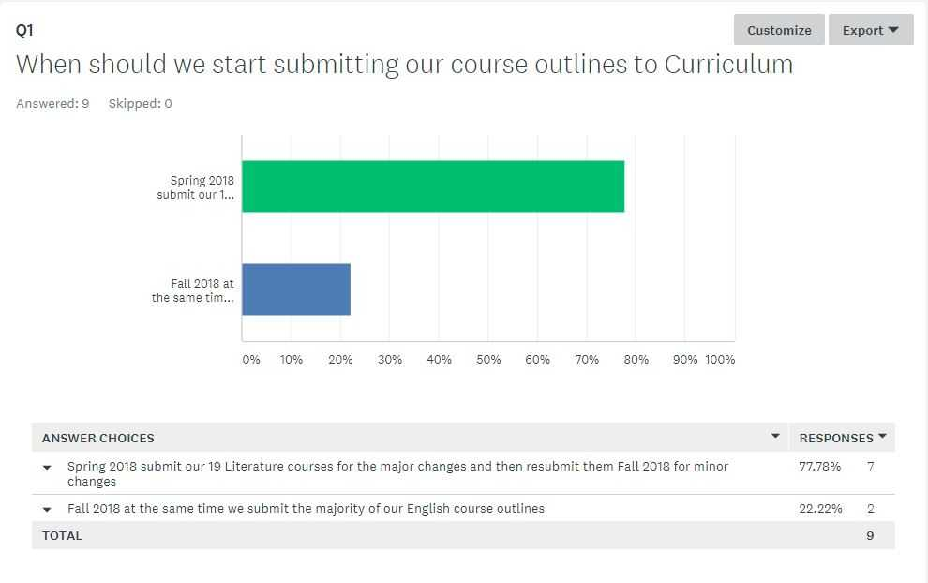
9 out of 13 people voted
7 voted to put the Literature courses through now
2 voted to wait until Fall

