Math 200
Mod 7 Example

The graph below shows a scatter plot associating the distance students in our class live from Skyline and the time it takes them to travel to school.

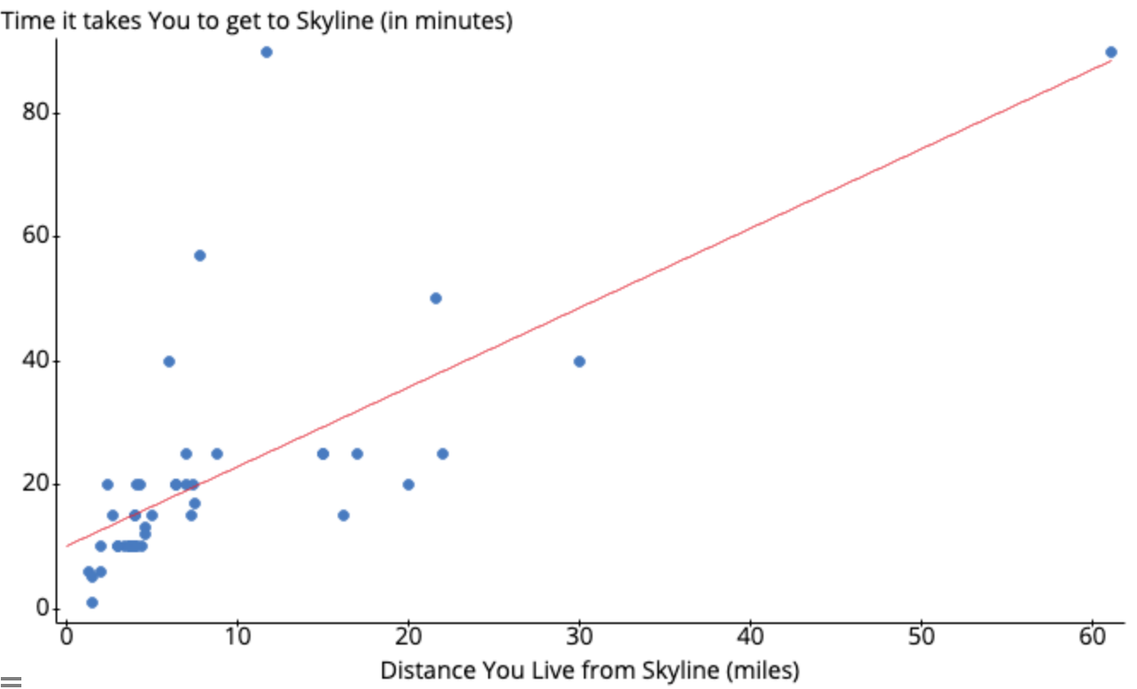 | 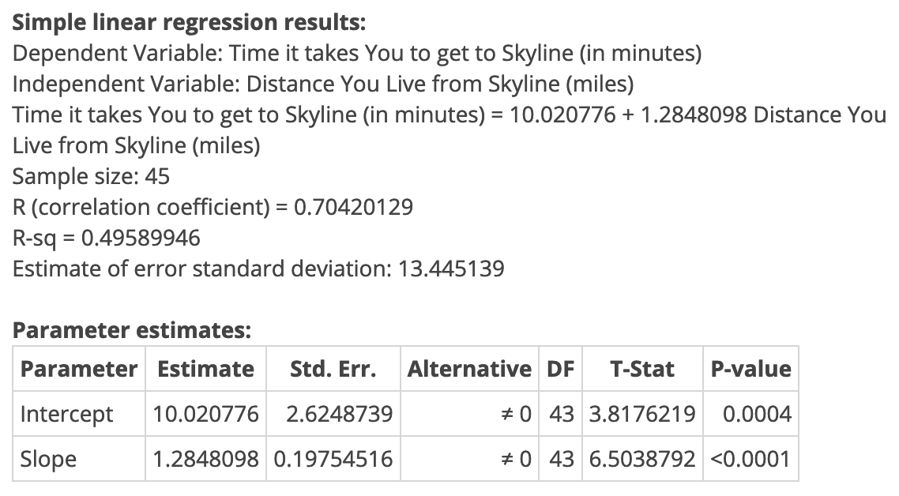  Notice that the intercept is the point (0, 10.02) and it means that a person who lives 0 miles from Skyline (lives at Skyline!) takes 10.02 minutes to get to Skyline. This is another example of extrapolation.
The statistics relating the associated variables are shown to the right of the graph.

- Without looking, estimate the correlation coefficient (r) for these data: r = 0.7

- Identify the explanatory variable: Distance (from Skyline)

- Round decimals to two places and rewrite the regression formula relating these data:

Time = 10.02 + 1.28 • Distance

- Use the equation from #3 to predict the travel time for someone who lives 9.5 miles from Skyline.
Time = 10.02 + 1.28 • 9.5
= 22 minutes

- Use the equation from #3 to predict the travel time for someone who lives 100 miles from Skyline.
Time = 10.02 + 1.28 • 100
= 138 minutes

- Why is the answer to #5 an inappropriate application of the regression equation?
The answer to #5 is an example of extrapolation. It assumes the trend in our data continues indefinitely – beyond the values in the data set.
This is an unreasonable assumption since there are no data to support the assumption that the pattern in the data goes on without change.

- Do there appear to be any outliers? If so, which? If not, why not?
Yes – at 60 miles (at the point (60, 90) and at 90 minutes (at the point (11, 90)).

- What is the slope of the line and what does it mean in this context? (Be sure to include units and numbers in your explanation).
The slope is 1.28.
The units of the slope are from response/explanatory: minutes/mile
This tells us that for each additional mile a person lives from Skyline, we expect their commute time to increase by 1.28 minutes.

- What is the r² value and what does it tell us about the regression line and these data?
r² = 0.5. This means that 50% of the variability in the Time it takes to get to Skyline is explained by the linear relationship with the Distance someone lives from Skyline.

