PLEADING WIZARD INSTRUCTIONS – LEGL 443/BUS 443

Hands-on Steps to Create a Pleading Master Template in Microsoft Word

How to Create A Pleading Word Document

Complete Steps 1 through 21

- Step No. 1 - Open Microsoft Word Software
- Step No. 2 - Select File
- Step No. 3 - Select New
- Step No. 4 - Select “Legal Pleadings”
- Step No. 5 - Select “Pleading Wizard” template

SCREENS AND HANDS-ON STEPS

SCREEN NO. 1:

- Step No. 6: Hands On - Select “Choose Task” button
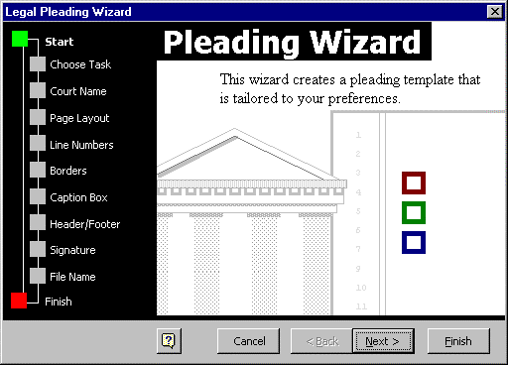
SCREEN NO. 2:

What do you want to do?

- Step No. 7: Hands On – Click on “Create a new Pleading template for another court” button
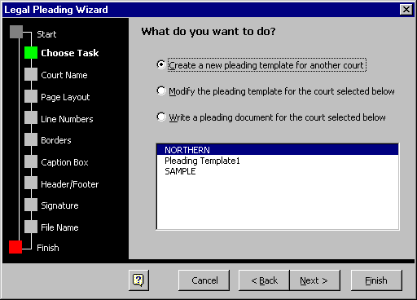

SCREEN NO. 3:

What is the name of the court, as it should appear on the pleading?

- Step No. 8a: Hands On –

Type - SUPERIOR COURT OF THE STATE OF CALIFORNIA (Enter)
Type - FOR THE COUNTY OF SAN MATEO (Enter)

How should the court name be aligned?

- Step No. 8b: Hands On – Select “Center” button
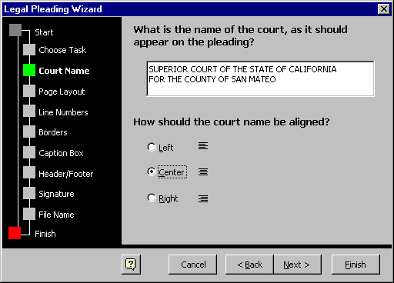

SCREEN NO. 4:

What are the page settings for this court?

- Step No. 9: Hands On - Select “Next” button at the bottom of the dialog box to accept default settings for the page settings
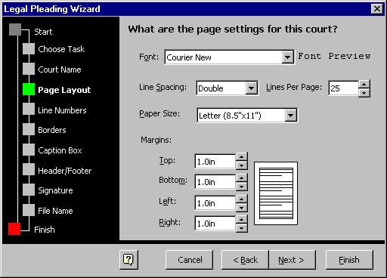

SCREEN NO. 5:

Do you want line numbers to appear on this pleading?

- Step No. 10: Hands On - Select “Next” button at the bottom of the dialog box to accept default settings for the line numbers pleading settings
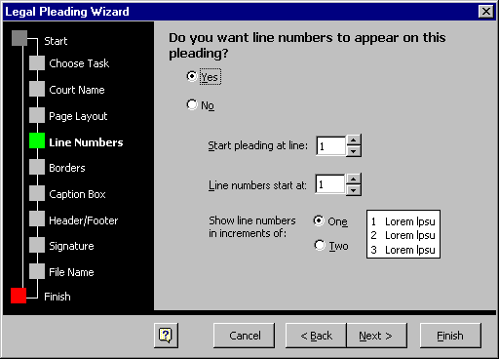

SCREEN NO. 6:

Do you want a border on this pleading?

Step No. 11: Hands On - Left – Select “Single” button
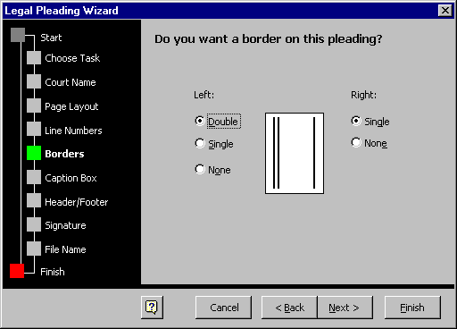
Right – Select “None” button

SCREEN NO. 7:

What style would you like for the caption box?

Step No. 12: Hands On – Select “Style 1” button as the caption box
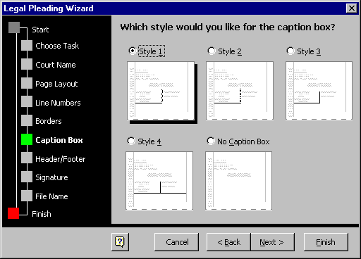

SCREEN NO. 8:

What information do you want at the beginning of the pleading?

Step No. 13a: Hands On – Select “Attorney and firm names” button

What information do you want in the footer?

Step No. 13b: Hands On – Select “Summary of pleading title” and “Page numbers” buttons
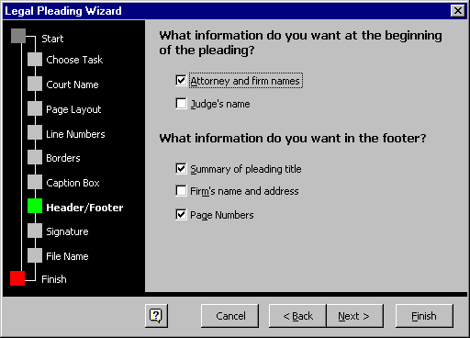

SCREEN NO. 9:

Do you want a signature block?

Step No. 14: Hands On – Select “No” button

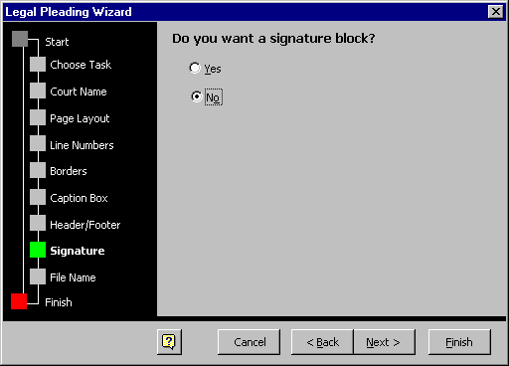

SCREEN NO. 10:

The settings for this court will be saved in a template. What name do you want for this file?

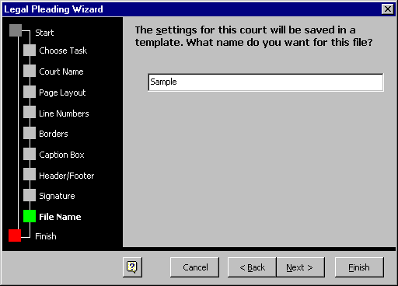
Step No. 15: Hands On – Type “Master” to save the pleading template document

SCREEN NO. 11:

Pleading Wizard: - Now that the template is saved, the Wizard is ready to help you fill in your content.

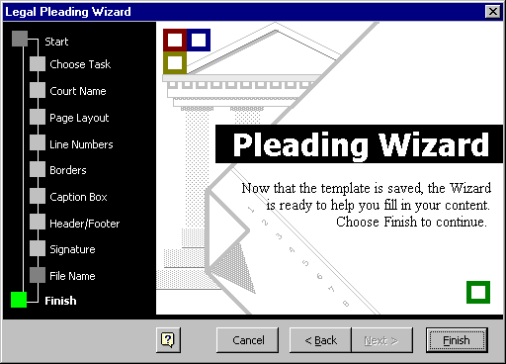
Step No. 16: Hands On – Select “Finish” to complete the “Master” pleading template

SCREEN NO. 12:

Pleading Wizard – This Wizard will help you write a new pleading for the chosen template.

Step No. 17: Hands On – Select “Parties” to fill in the plaintiff and defendant information application to the “Master” pleading template
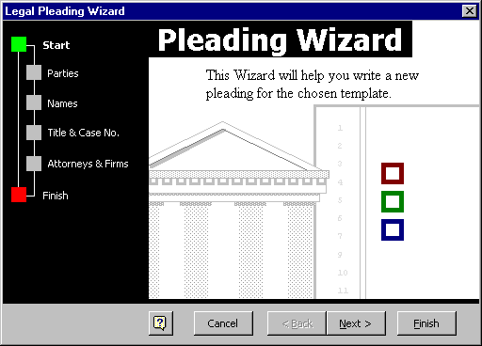

SCREEN NO. 13:

Which parties are involved?

Step No. 18: Hands On – Select “Plaintiff vs. Defendant” button
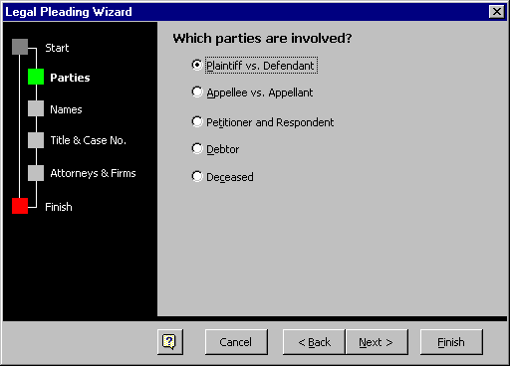

SCREEN NO. 14:

What are the names of the plaintiffs?

Step No. 19a: Hands On – Type “MARSHA MARIGOLD” in UPPERCASE letters

What are the names of the defendants?

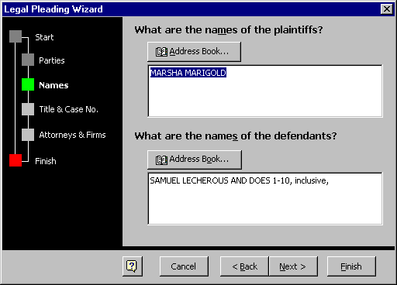
Step No. 19b: Hands On – Type “SAMUEL LECHEROUS AND DOES 1-10”, in UPPERCASE letters and “inclusive,” in lowercase letters

SCREEN NO. 15:

What is the case number?

Step No. 20a: Hands On – Leave blank

How many firms are filing this pleading?

Step No. 20b: Hands On – Select “1”

What is the full title for the pleading?

Step No. 20c: Hands On – Type “COMPLAINT FOR PERSONAL INJURIES AND PROPERTY DAMAGE” in UPPERCASE

What is the pleading title summary?

Step No. 20d: Hands on – Type “COMPLAINT FOR PERSONAL INJURIES AND PROPERTY DAMAGE” in UPPERCASE
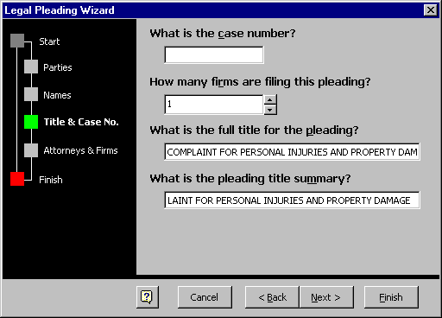

SCREEN NO. 16:

What are the names of your firm’s attorneys for this case?

Step No. 21a: Hands On – Type “JERRY MASON, ESQ. (SBN: 8842368)” in UPPERCASE letters

Include for Attorney(s) for?

- Step No. 21b: Hands on – Check Box and Select “Plaintiff” from the pull down menu

What is your firm’s name and address?

- Step No. 21c: Hands on – Type COLVIN, MASON & NORMAN (Enter)
Transamerica Pyramid (Enter)
600 Montgomery Street, Suite 600 (Enter)
San Francisco, California 94111 (Enter)
Telephone: 415-433-8000 (Enter)

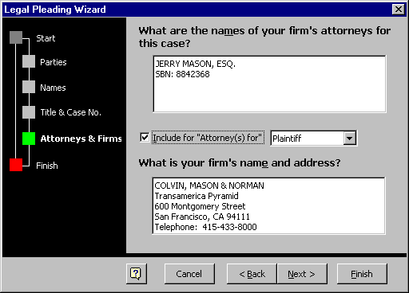

SCREEN NO. 17:

- Step No. 22: Hands on – Select “Finish” button and wait for the pleading document to appear on the screen
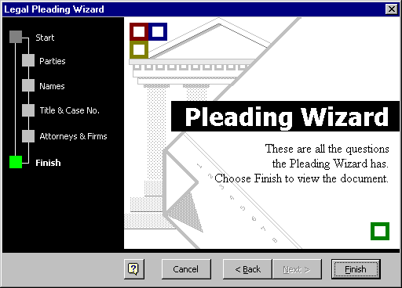

C:\MyDocuments\WORDDocuments\WIZARD(Desktop 12-19-99)

