Lecture and general Plant Biology resources

- What are the two forms of reproduction can be performed by plants?

- What is pollen? Where is pollen produced? Describe the structure and function of pollen.

- What name is give to the transfer of pollen from one plant to another?

- Describe the differences in flower structure between a typical wind pollinated flower and a typical animal pollinated flower.

- Name and describe the function of each of the whorls of modified leaves that make up a typical flower (perfect and complete).

- Provide definitions for each of the following terms; complete flower, incomplete flower, perfect flower, imperfect flower.

- To which taxonomic Division do the flowering plants belong?

- When did flowering plants first appear in the fossil record?

- Label the following diagram

- 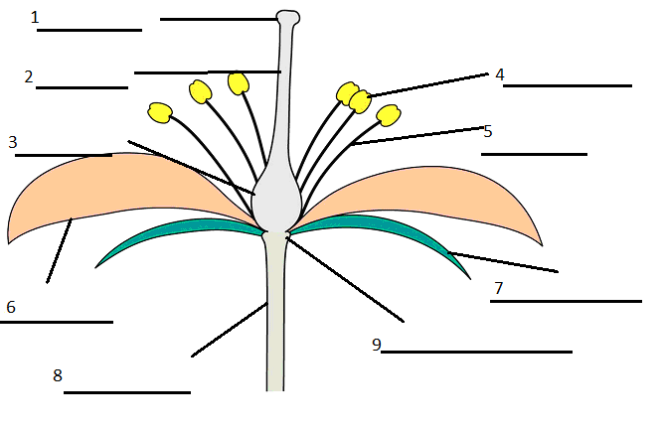

- Name the male organ of a flower, what name is given to each of the two component parts? Name the female organ of a flower, what name is given to each of the three component parts?

- What terms are used to describe the two different forms of floral symmetry.

- Describe the location, and the appearance, and the function of sepals.

- Describe the location, and the appearance, and the function of petals.

- Provide definitions for each of the following terms; monoecious, dioecious, staminate, and pistillate.

- Describe the location, and the appearance, and the function of ovary. What are ovules, what role do they have in plant reproduction?

- Draw and describe the three different ovary positions.

- What is an inflorescence? Draw and name four different types of inflorescences.

- Draw and describe the flowers unique to the Asteraceae (Daisy Family).

- Compare and contrast the vegetative and reproductive structures of monocots and dicots.

- What is the function of fruit?

- Provide examples of the following types of fruits; fleshy simple fruit, aggregate fruit, simple dry dehiscent, simple dry indehiscent, multiple fruit.

- What type of fruit is a strawberry? Explain how the seeds of a strawberry are on the outside.

Resources
Sex and Squash Blossoms
http://thelocavoresdilemma.wordpress.com/2011/07/24/sex-and-squash-blossoms/
Flowers Fruit and Seeds
http://academic.kellogg.edu/herbrandsonc/bio111/seeds_fruits_flowers.htm

